**Environment:** Analysis was performed on TEST environment.

General info:

|  |  |  |  |  |  |
| --- | --- | --- | --- | --- | --- |
|  | **Host** | **Type** | **IP** | **Hosted Applications** | **Ports** |
| STAGING | EPUAKYIW1686T1 | VM | 10.17.175.108 | EPUAKYIW1686T1.kyiv.epam.com | 8080, 4444 |

System resources (TEST env):

|  |  |  |  |
| --- | --- | --- | --- |
| **Configuration** | **CPU, GHz** | **Memory, Gb** | **Disk size, Gb** |
| 1 | 1 | 11.2 | 100 |
| 2 | 2 | 11.2 | 100 |
| 3 | 3 | 11.2 | 100 |
| 4 | 3 | 2 | 100 |
| 5 | 3 | 3 | 100 |
| 6 | 3 | 4 | 100 |
| 7 | 3 | 6 | 100 |
| 8 | 3 | 8 | 100 |
| 9 | 1 | 8 | 100 |

**Test scenario**

There is a combined scenario which is to include the scripts:

• Task 4 (admin)

• Task 5 (editor)

• Task 6 (anonymous)

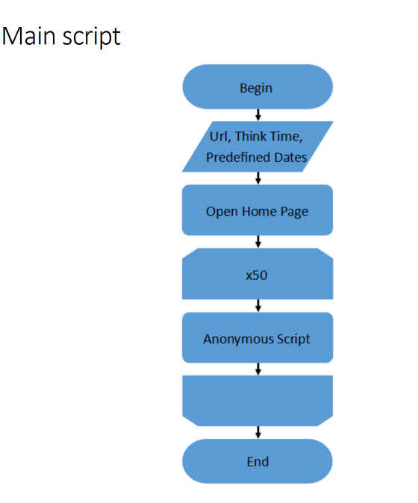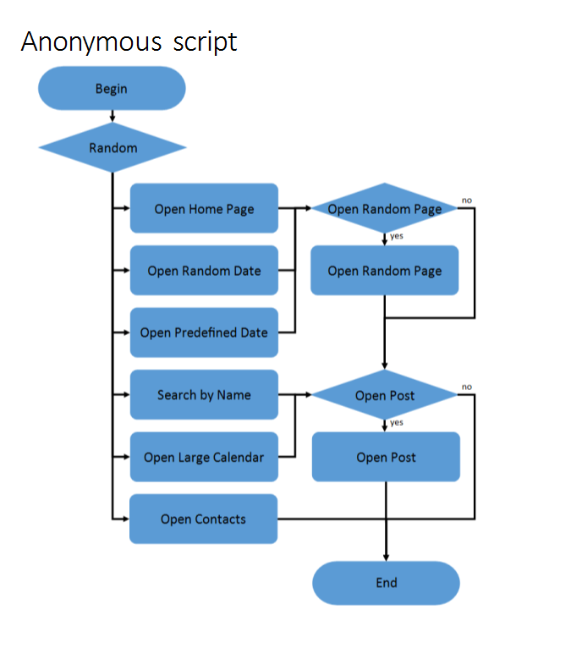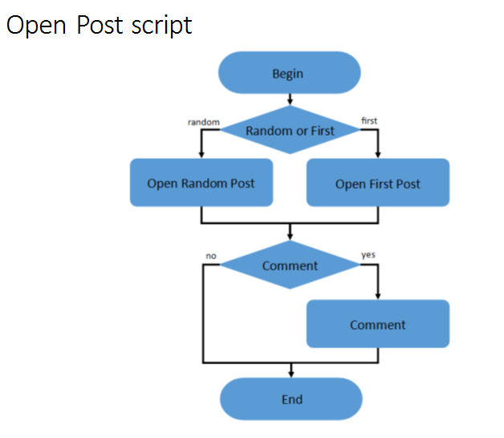

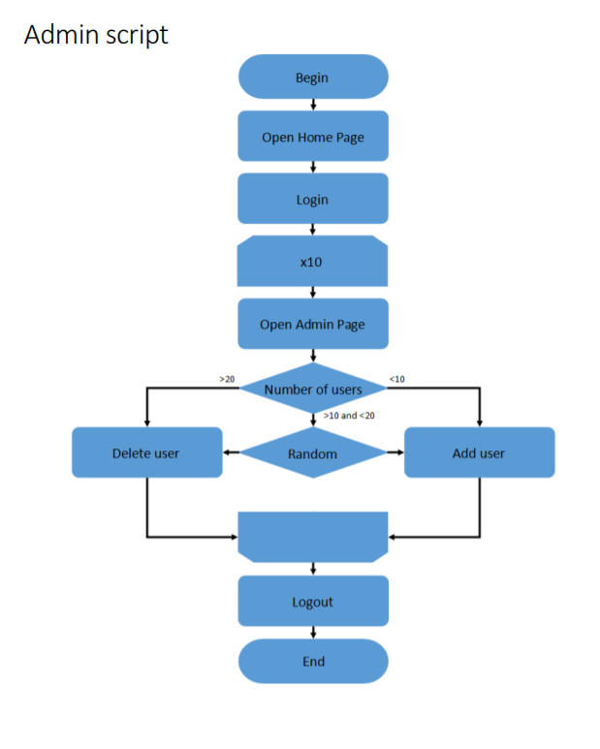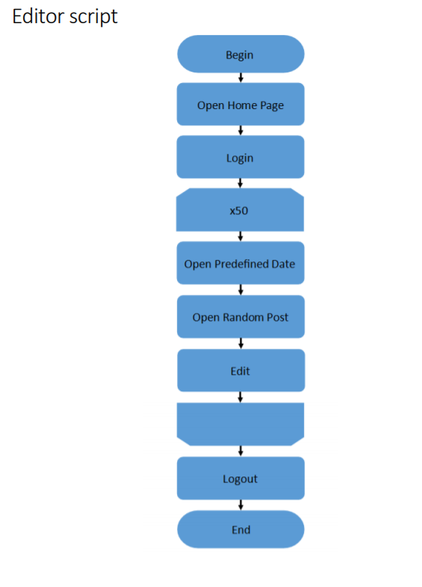

**Test conditions**

|  |  |
| --- | --- |
| **Transaction** | **Condition for anonymous script** |
| open home page | 15% |
| open random date | 10% |
| open predefined date | 30% |
| search by name | 30% |
| open large calendar | 10% |
| open contacts | 5% |
| open random page | 50% |
| open post | 80% |
| open random post | 65% |
| open first post | 35% |
| add comment | 20% |

**Test Setup**

|  |  |
| --- | --- |
|  | Condition |
| number of virtual users | Up to 150 – Anonymous  2 – Admins  2 – Editors |
| ramp-up period(sec) | 750 – Anonymous  30 – Admin  30 ­­­– Editor |
| duration(sec) | 900 |
| think time (sec) | 3-5 |

**Test Summary**

1 For 2 and 3 cores we can see that process time grows significantly when we faced with saturation point and adding more load leads to the application becomes unresponsive however for 1 core works fine and how you can see for configuration 1 and 9 max response time is less than 10 seconds for all requests.

2 For configuration 8 and 9 are shown detailed graphics for % Processor Time and Memory usage graphs. This problem needs to investigate deeper because it not problems with cache see attached screens.

**Recommendation**

1 Deeper investigation with memory usage.

2 For now, the best VM configuration is 9, please use it for application.

**Results: graphs and tables(for more details open dashboard HTMLReport > index)**

1 Statistics

1 Configuration

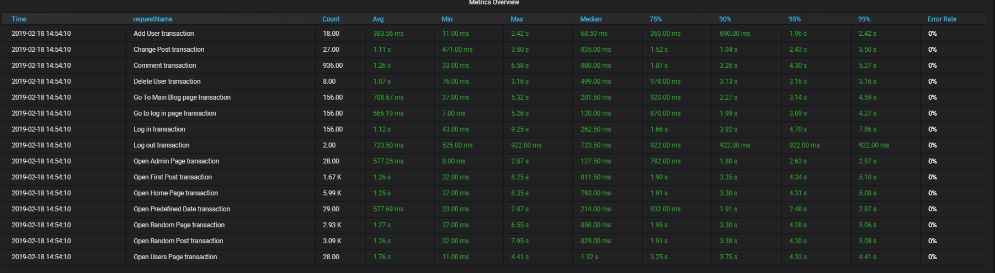

2 Configuration

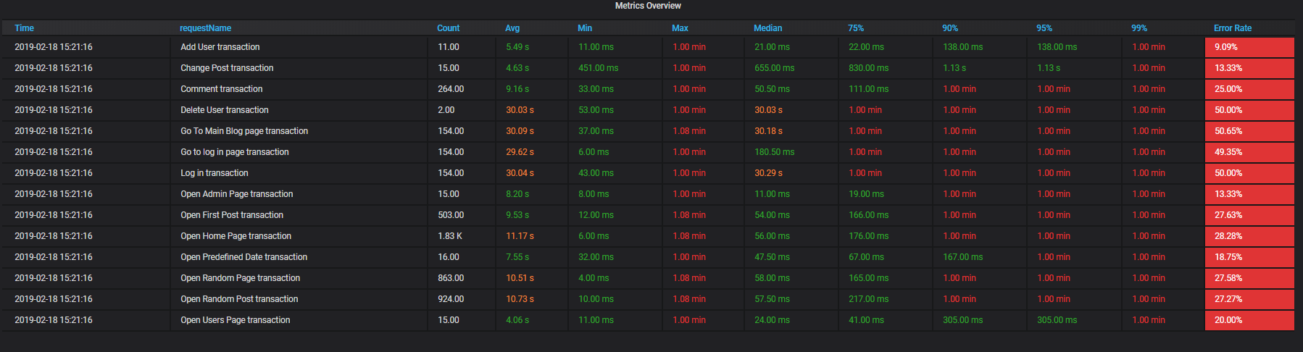

3 Configuration

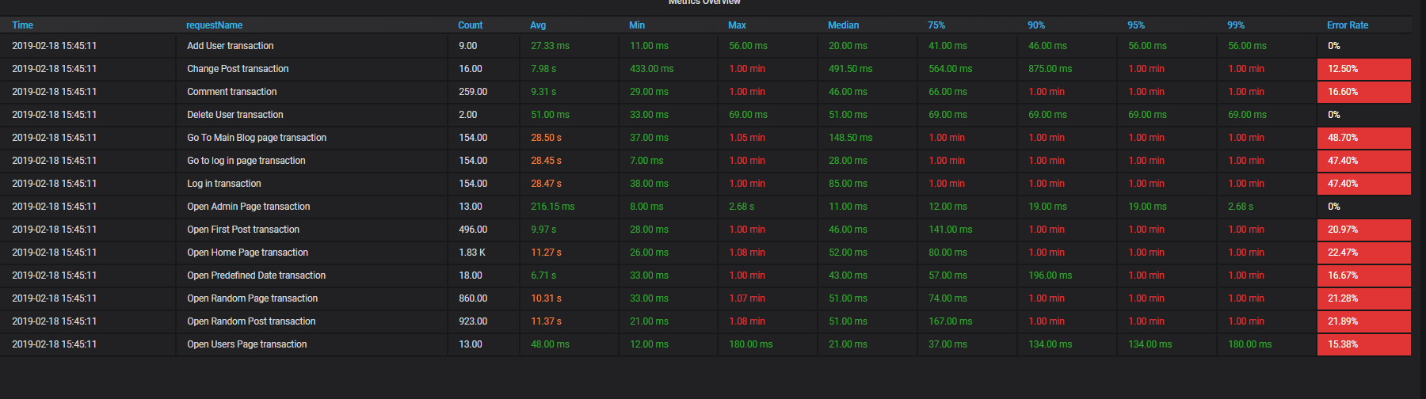

4 Configuration

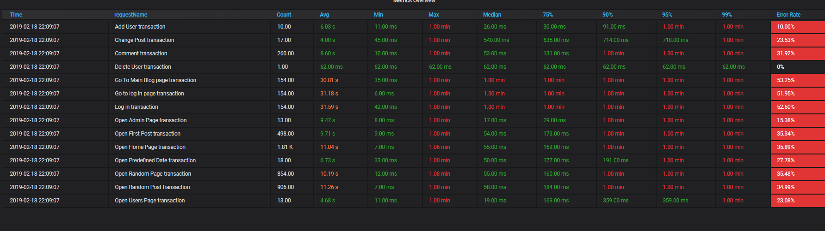

8 Configuration

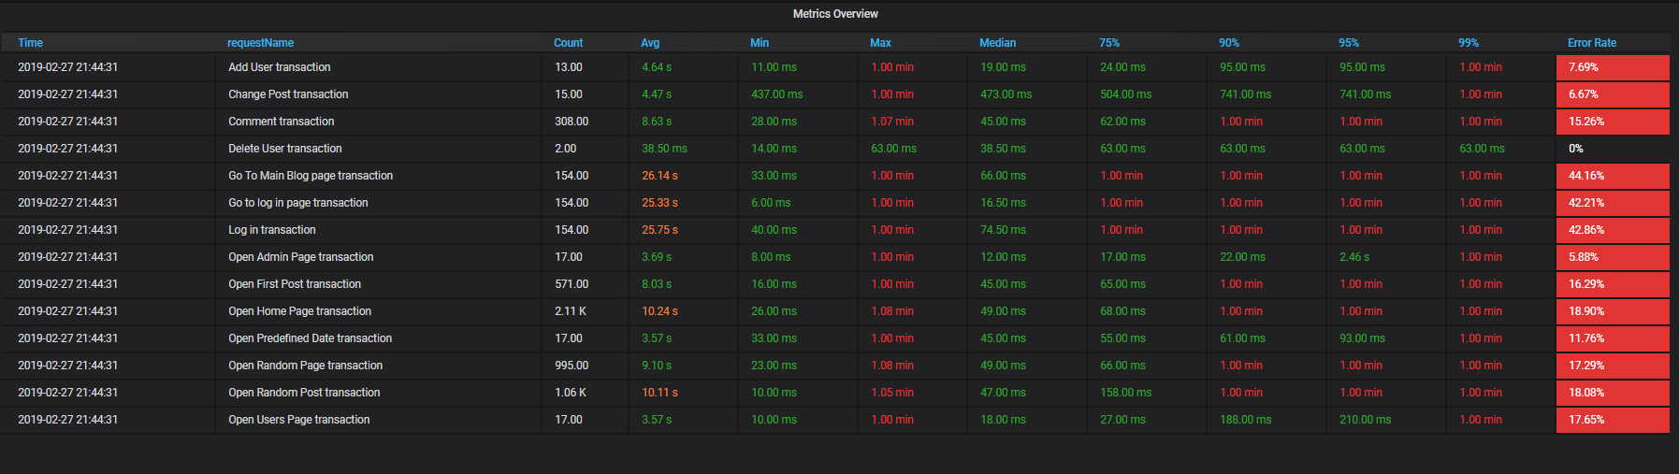

9 Configuration

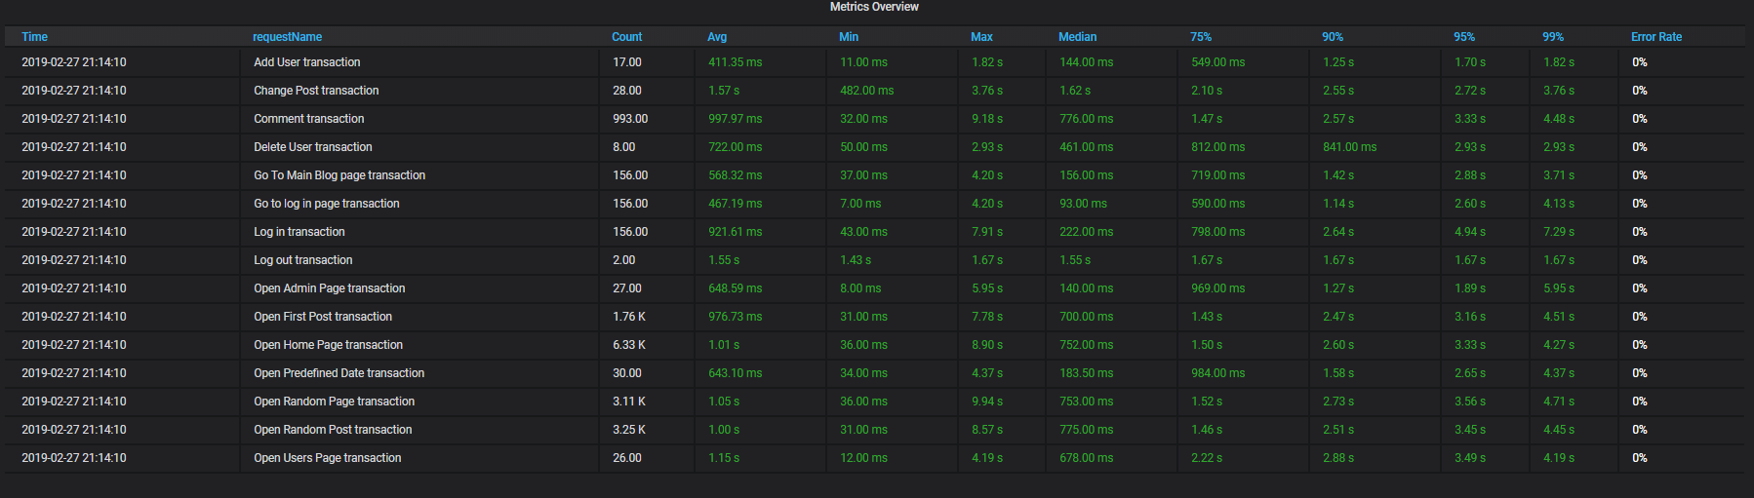

2 Number of active threads vs throughput graph

1 Configuration

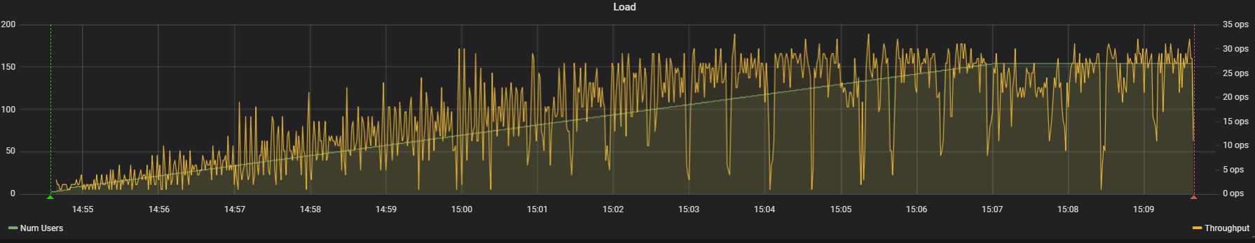

2 Configuration

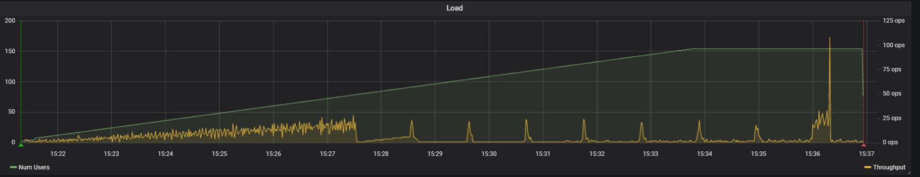

3 Configuration

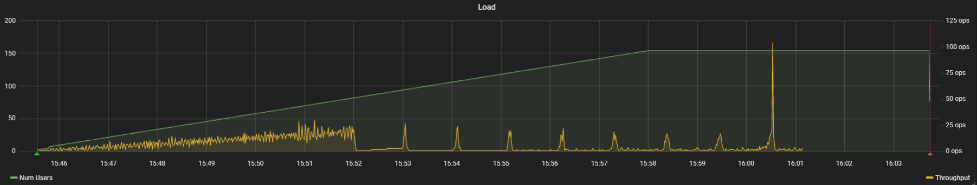

4 Configuration

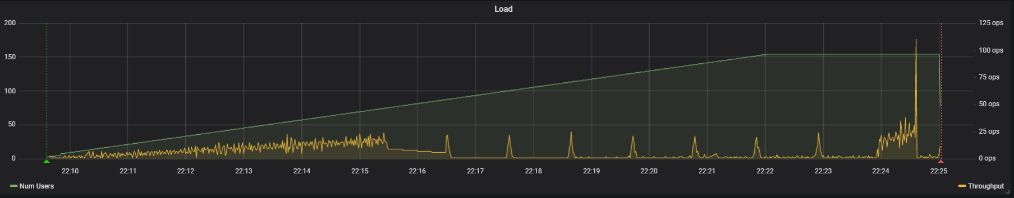

8 Configuration

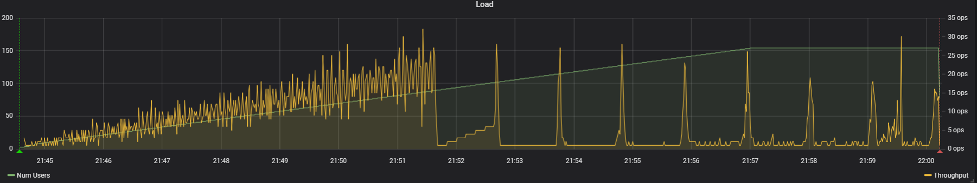

9 Configuration

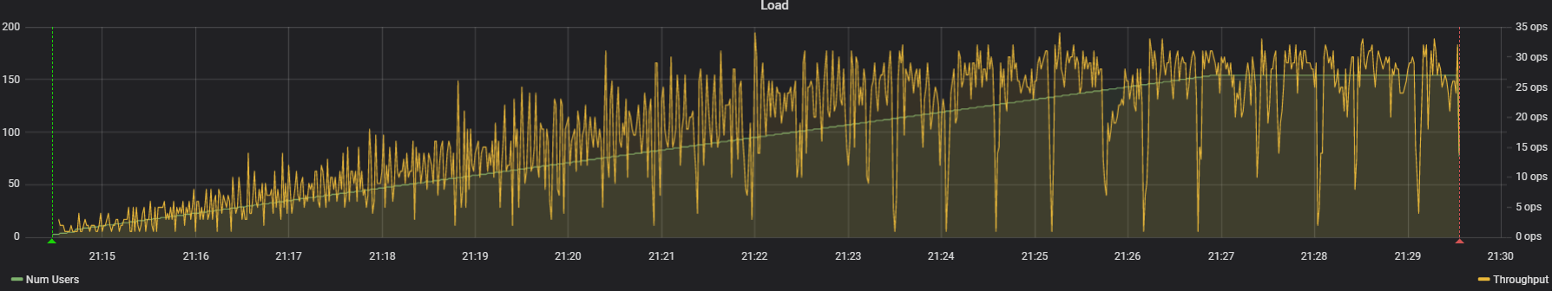

3 (CPU,Memory) graphs

1 Configuration

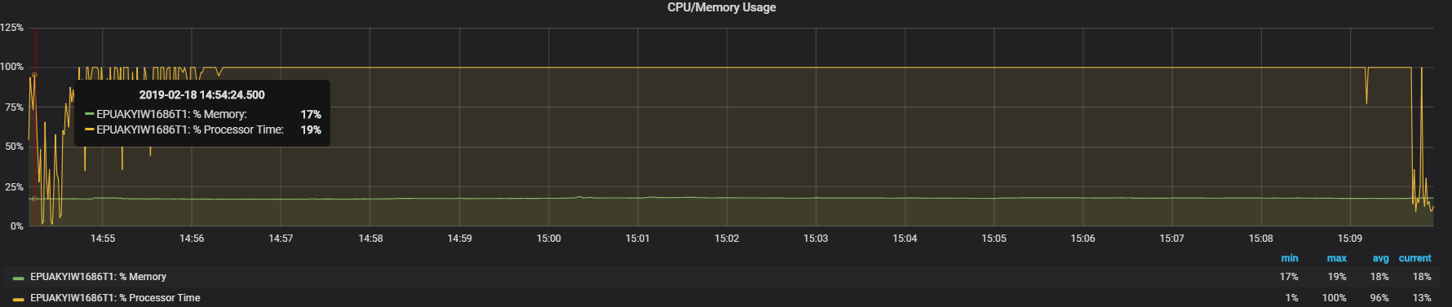

2 Configuration

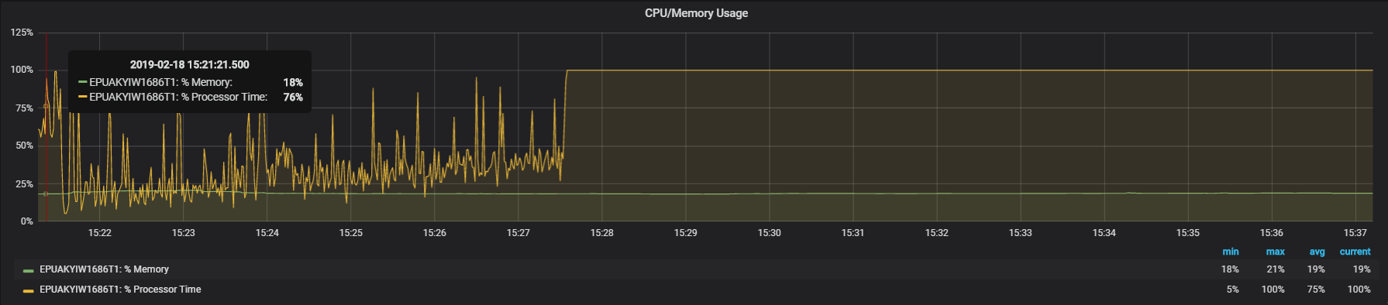

3 Configuration

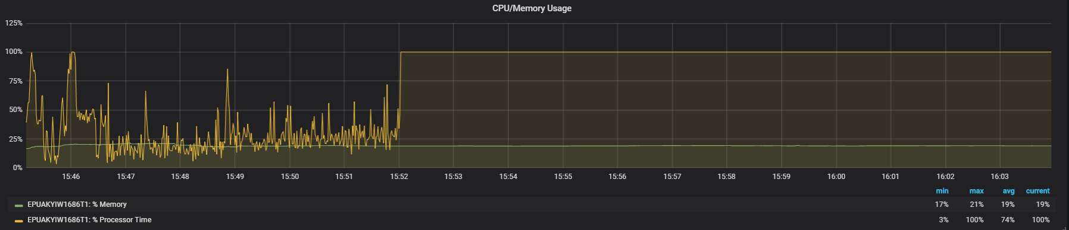

4 Configuration

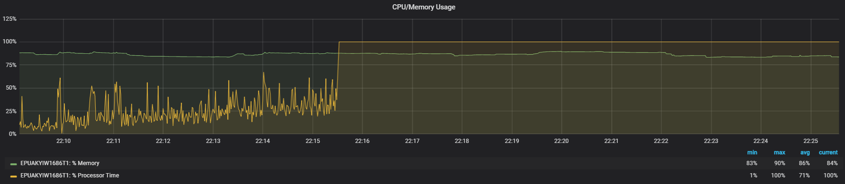

8 Configuration

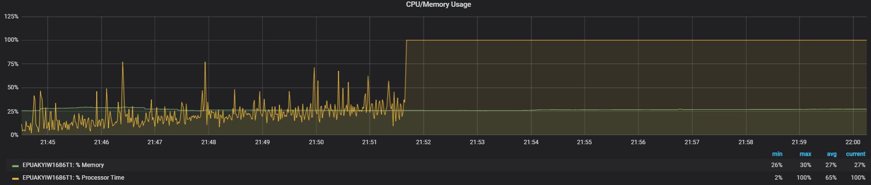

9 Configuration

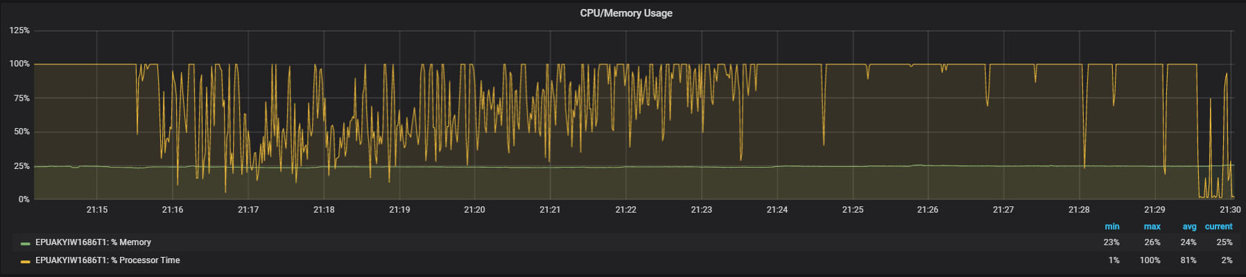

4 % Processor Time and Memory usage graphs

8 Configuration

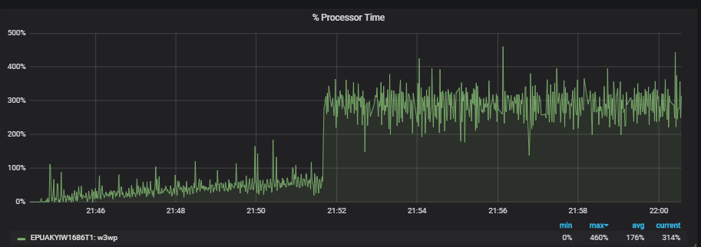

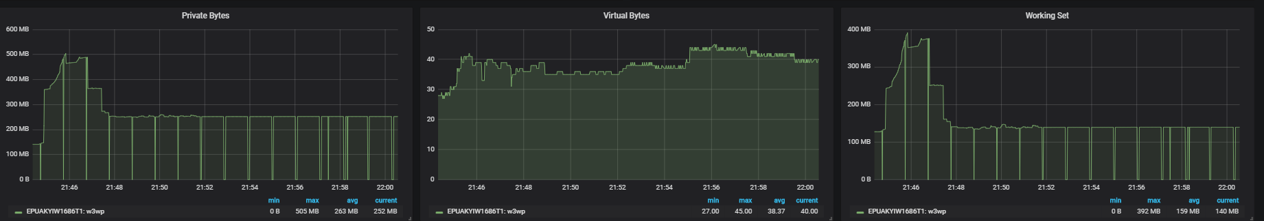

9 Configuration

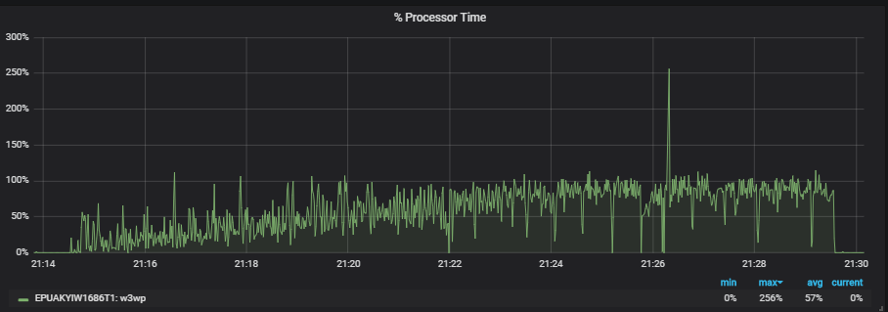

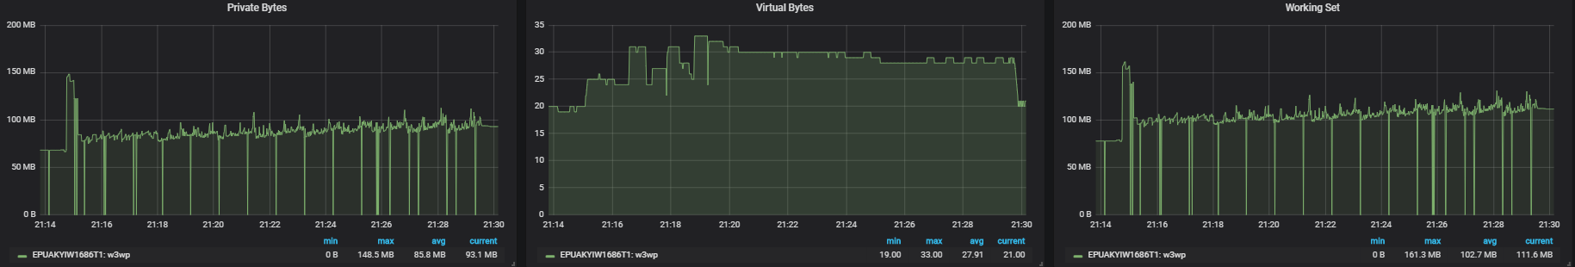

5 IIS, ASP.NET Applications

8 Configuration

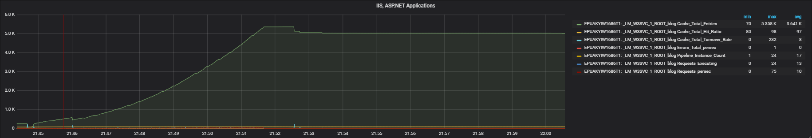

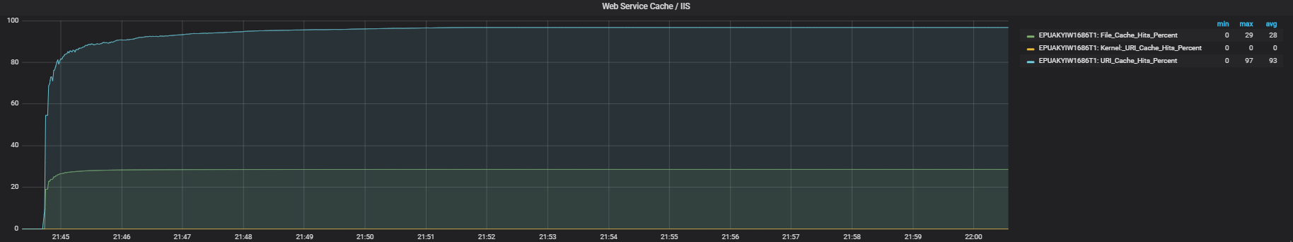

9 Configuration

